**Merging two images and giving vintage look**

**Introduction:**

Merges given images into a single image in right order. This will be helpful in a situation when you have to generate a preview of multiple images into a single image. Merging photos together gives a cinematic, professional look to any combination of photos. We can use it in editing purpose.

**Requirements:**

**High Level Requirements:**

| **HLR** | **Description** |
| --- | --- |
| HLR-01 | Add images |
| HLR-02 | Graph |
| HLR-03 | Picture enhancing |

**Low Level Requirements:**

| **LLR** | **Description** |
| --- | --- |
| LLR-01 | vintage look |
| LLR-02 | can give PNG OR JPG OR JPEG |

**Applications**

-> can make photo editing apps.. EX:- Photo Grid,Photo Collage Maker,Split P.

-> Use in movies.

-> Can give vintage look.

**Block Diagram:**

[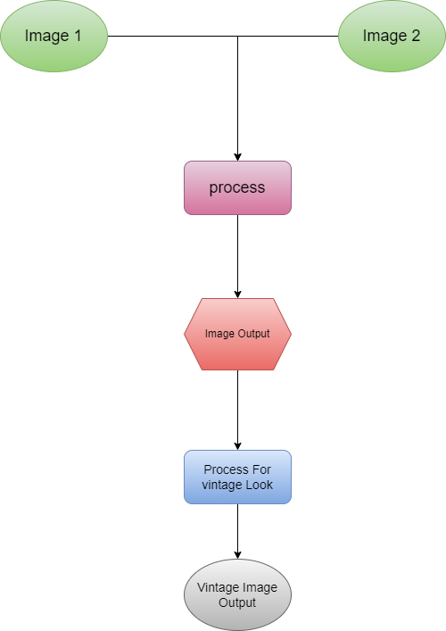](https://user-images.githubusercontent.com/98813939/160235064-d22e420c-0f5a-45d9-bc04-d8880d1dcb21.png)

**4W 1H**

**What**

Merging two images and giving vintage output

**where**

We can use in editing

**who**

Everyone

**How**

By using the technique adding matrix

**SWOT analysis**

**Strengths:**

I enjoy taking/editing photos I work well with a few other people I have the right camera equipment and editing software I like to make sure I get tasks done on time

**Weaknesses:**

I’m shy so I have to get used to the people I work with I like to do jobs properly so I’d have to be told exactly how/what to do. I don’t have the correct qualifications needed to be a photo editor. (degree)

**Opportunities:**

I know people who like photography too so I could help them with picture editing I take photos myself which gives me more experience with photography and photo editing.

**Threats:**

Some people may get better opportunities A lot of photographers edit their photos themselves so an editor may not be needed.